SUPERMARKET

Management System

**A MINI-PROJECT REPORT**

***Submitted by***

**MAIGYANA SIVA S – 2116220701157**

***in partial fulfilment of the award of the degree of***

**BACHELOR OF ENGINEERING**

**IN**

**COMPUTER SCIENCE AND ENGINEERING**



**RAJALAKSHMI ENGINEERING COLLEGE AUTONOMOUS, CHENNAI**

**NOV/DEC, 2024**

**BONAFIDE CERTIFICATE**

Certified that this mini project “**Supermarket Management System**” is the bonafide work of “**MAIGYANA SIVA S (2116220701157)”** who carried out the project work under my supervision.

**SIGNATURE Mrs. JANANEE V,**

**Assistant Professor,**

**Computer Science & Engineering Rajalakshmi Engineering College Thandalam, Chennai -602105.**

Submitted for the End semester practical examination to be held on

**INTERNAL EXAMINER EXTERNAL EXAMINER**

**ACKNOWLEDGEMENT**

I express my sincere thanks to my beloved and honourable chairman MR.S.MEGANATHAN and the chairpersonDR.M.THANGAM MEGANATHAN for their timely support and encouragement

I am greatly indebted to my respected and honourable principal **Dr. S.N.MURUGESAN** for his able support and guidance.

No words of gratitude will suffice for the unquestioning support extended to us by my head of the department **Dr. P. KUMAR,** and my Academic Head **Dr.N.SABITHA,** for being ever supporting force during my project work.

I also extend my sincere and hearty thanks to my internal guide **Mrs. JANANEE V** for her valuable guidance and motivation during the completion of this project.

My sincere thanks to my family members, friends and other staff members of Computer Science and Engineering.

Maigyana siva S 2116220701157

**ABSTRACT**

The Supermarket Management System is a comprehensive solution designed to digitize and optimize the day-to-day operations of a supermarket. This system provides a centralized platform to manage core processes such as inventory management, sales transactions, customer relationship management (CRM), employee management, and reporting. The inventory module keeps track of stock levels in real-time, automatically updating quantities as sales are made and notifying staff when restocking is required. The sales module supports multiple payment methods, generates detailed invoices, and integrates with the CRM to maintain customer records for loyalty programs and personalized marketing.

The system also facilitates supplier management, ensuring seamless procurement processes. Reports on sales performance, stock turnover, and employee efficiency are generated to provide valuable insights for better decision-making. The intuitive user interface, designed for both staff and management, minimizes training time and reduces operational errors. Additionally, the system includes robust security features to protect sensitive data, ensuring compliance with industry standards. By automating critical tasks, this project aims to enhance productivity, improve customer satisfaction, and reduce costs for supermarket operators.

**TABLE OF CONTENTS**

|  |  |
| --- | --- |
| **CHAPTER NO. TABLE** | **PAGE NO.** |
| **ABSTRACT** | 4 |
| **1. INTRODUCTION** | 6 |
| 1.1. INTRODUCTION | 6 |
| 1.2. SCOPE OF WORK |  |
| 1.3. AIM AND OBJECTIVE OF THE PROJECT | 7 |
| 2. **SYSTEM SPECIFICATIONS** | 8 |
| 2.1. HARDWARE SPECIFICATIONS | 8 |
| 2.2. SOFTWARE SPEECIFICATIONS | 8 |
| **3. ARCHITECTURE DIAGRAM** | 9 |
| **4. MODULE DESCRIPTION** | 10 |
| **5. SYSTEM DESIGN** | 12 |
| 5.1. USE CASE DIAGRAM | 12 |
| 5.2. ER DIAGRAM | 13 |
| 5.3. DATA FLOW DIAGRAM | 14 |
| 5.4. ACTIVITY DIAGRAM | 17 |
| **6. SAMPLE CODING** | 18 |
| **7. SCREEN SHOTS** | 23 |
| **8. CONCLUSION** | 26 |
| **9. REFERENCES** | 27 |

**CHAPTER 1 INTRODUCTION**

# Overview

The project is on Supermarket management. Supermarket is the place where customers come to purchase their daily using products and pay for that. So there is a need to calculate how many products are sold and to generate the bill for the customer. In our project employee of the super market will enter the data and stores data into database and they generate the bill to customer of purchased items**.**

# Purpose

The main purpose of this project is to provide a user friendly interface commuters to easily manage and retrieve the information. ➢ In our project supermarket management we register employee and customer information and store the information in database. ➢ Maintains of database of all related forms. ➢ Employee can make changes and generate the bill

# Scope:

This project aims at developing system software which would cater to the needs of the people. So we aim to implement such a system that allows the user to have the facility at any place and access the required information. It can be easily customized as per the requirements and available resources to suit the needs of different users Objectives:

1. **Automate Billing Process:** To develop a system that automates the entire electricity billing process, from meter reading to bill generation, ensuring accurate and timely invoicing for consumers.
2. **Enhance Consumer Convenience:** To provide a user-friendly portal where consumers can easily access their electricity usage, view bills, make payments, and receive notifications regarding due dates and payment statuses.
3. **Reduce Administrative Workload:** To minimize the manual efforts involved in billing and payment tracking, allowing utility providers to focus on higher-level management tasks.
4. **Ensure Accurate Meter Readings:** To integrate automated meter reading (AMR) technology or manual input options for capturing precise electricity consumption data and reducing billing errors.
   1. **EXISTINGSYSTEM**

Many Supermarkets use this type of billing system for a decade. It is also Improved many times according to requirements of sellers and customers. It Does the same work that is calculating the bill, gives it to the customer and Maintain proper database. They are accurate in calculation and printing, they also generate records. A new concept is also added in the billing system is that they also maintain Relationships with the customers who purchase more products from the store regularly. System also concerns their requirements and gives them more commission. It also shows the overall profit and profit on a particular product and give repots which items are required and which have cross their expiry date..

**CHAPTER 2 SYSTEMSPECIFICATIONS**

1. **HARDWARE SPECIFICATIONS**

Processor **:** Pentium IV Or Higher

Memory Size **:** 128 GB (Minimum)

HDD **:** 40 GB (Minimum)

1. **SOFTWARE SPECIFICATIONS**

Operating System **:** WINDOWS 7 AND PLUS Front – End **:** HTML, CSS, JS

Back – End **:** MONGODB

**CHAPTER 3 ARCHITECTURE DIAGRAM**

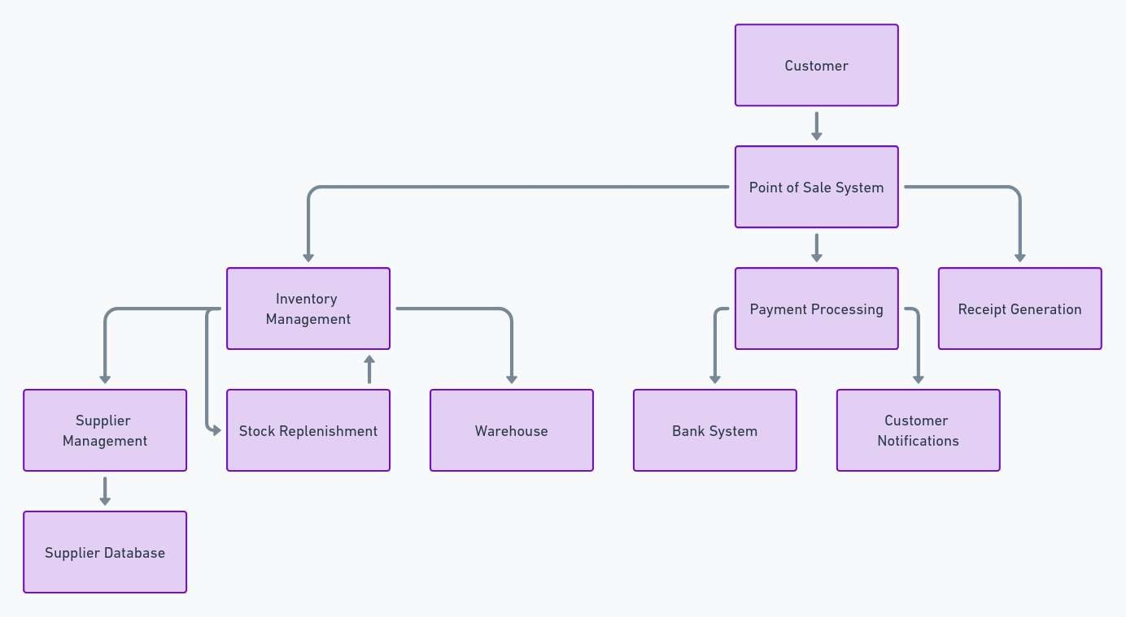

**CHAPTER 4 MODULE DESCRIPTION**

# User Registration and Login Module:

The User Registration and Login Module for an Electricity Bill Management System plays a critical role in ensuring secure and smooth access for users. During registration, users provide essential information such as their name, email, phone number, address, and password. The system validates these inputs, ensuring that the email format is correct, the password is strong, and the email or phone number is unique. Upon successful registration, users receive a confirmation via email or SMS to verify their identity, ensuring that only verified users can log in.

# User Testing Module:

The User Testing Module for an Electricity Bill Management System is critical to ensuring that the system functions effectively and meets user needs. It involves testing the system's usability, functionality, performance, and security with real users or testers simulating typical user interactions. The process begins with creating a detailed test plan and defining scenarios, such as user registration, logging in, bill payment, and profile updates. Functional testing ensures that these actions work as expected, while usability testing evaluates how intuitive and easy the system is to navigate for users.

# Testing Status Module:

The Testing Status Module in an Electricity Bill Management System provides a real-time overview of the testing progress, tracking the status of all test cases across categories like functionality, usability, and security. It shows which tests have passed, failed, or are pending, and highlights critical issues that need attention. By offering transparency and monitoring the completion rate, this module ensures all stakeholders stay informed about the system's readiness for deployment and can act promptly to address any remaining problems.

# Admin Module:

The Admin Module in an Electricity Bill Management System is responsible for managing the system’s core administrative functions and providing the tools necessary for administrators to oversee system operations. Through this module, admins can manage user accounts, handle billing operations, monitor payments, and generate reports. Key functionalities include the ability to add, update, or deactivate customer accounts, manage tariff plans, and adjust billing rates. Additionally, admins can oversee payment records, verify transactions, and resolve billing disputes.

The module also provides administrative access to generate system reports, such as total revenue, outstanding payments, and usage statistics. Security features like role-based access control are integrated to ensure that only authorized personnel can access sensitive areas of the system. The Admin Module ensures efficient management of the system's operational aspects, enabling administrators to maintain smooth and secure functioning of the entire electricity billing system.

**CHAPTER 5 SYSTEM DESIGN**

* 1. **USE CASE DIAGRAM**

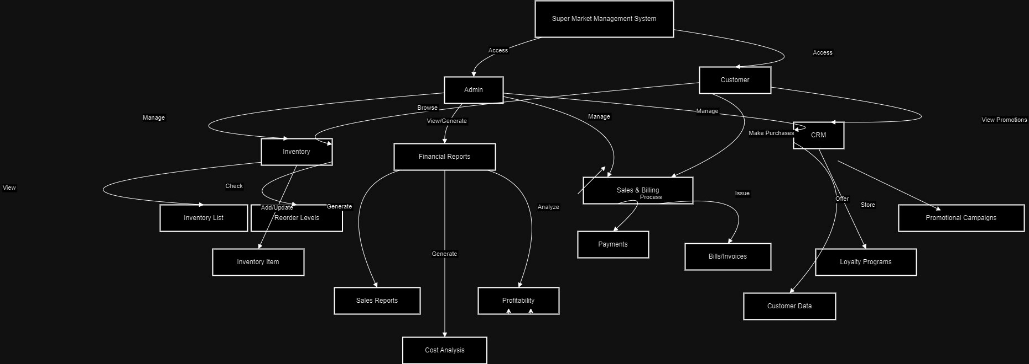

* 1. **ER-DIAGRAM**

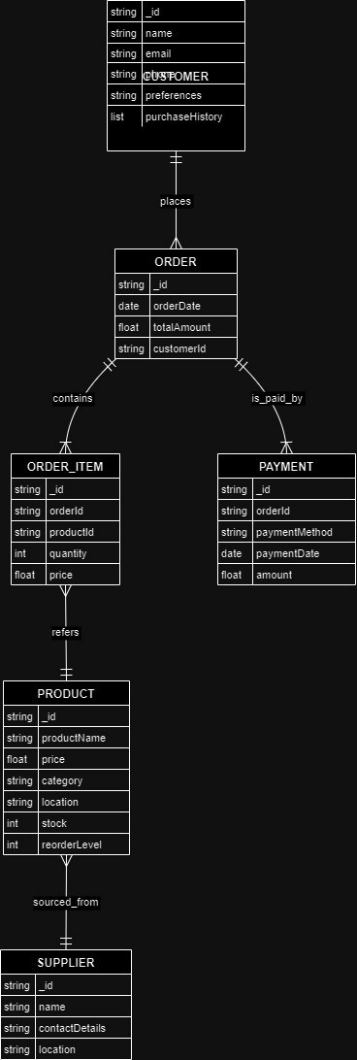

* 1. 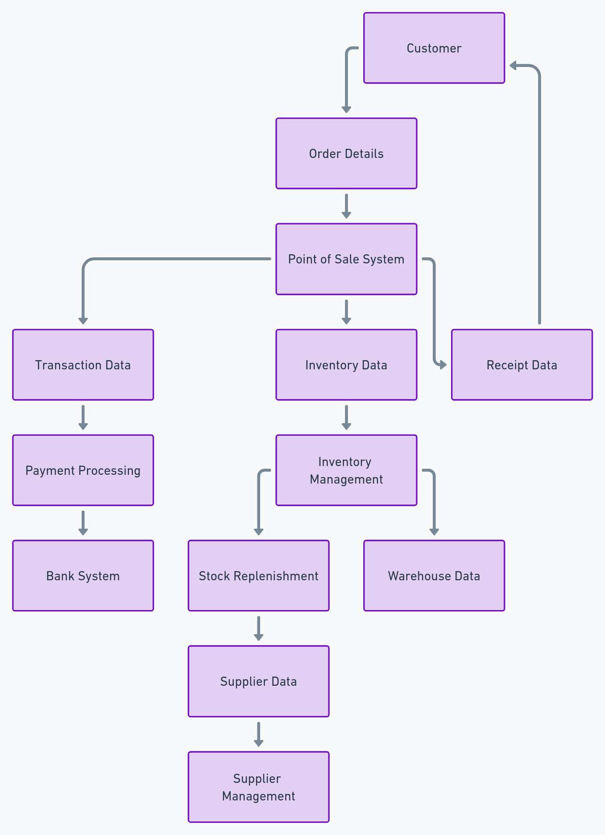**DFD DIAGRAM**
     1. **FIRST LEVEL DFD**
     2. **SECOND LEVEL DFD**
  2. **ACTIVITY DIAGRAM**

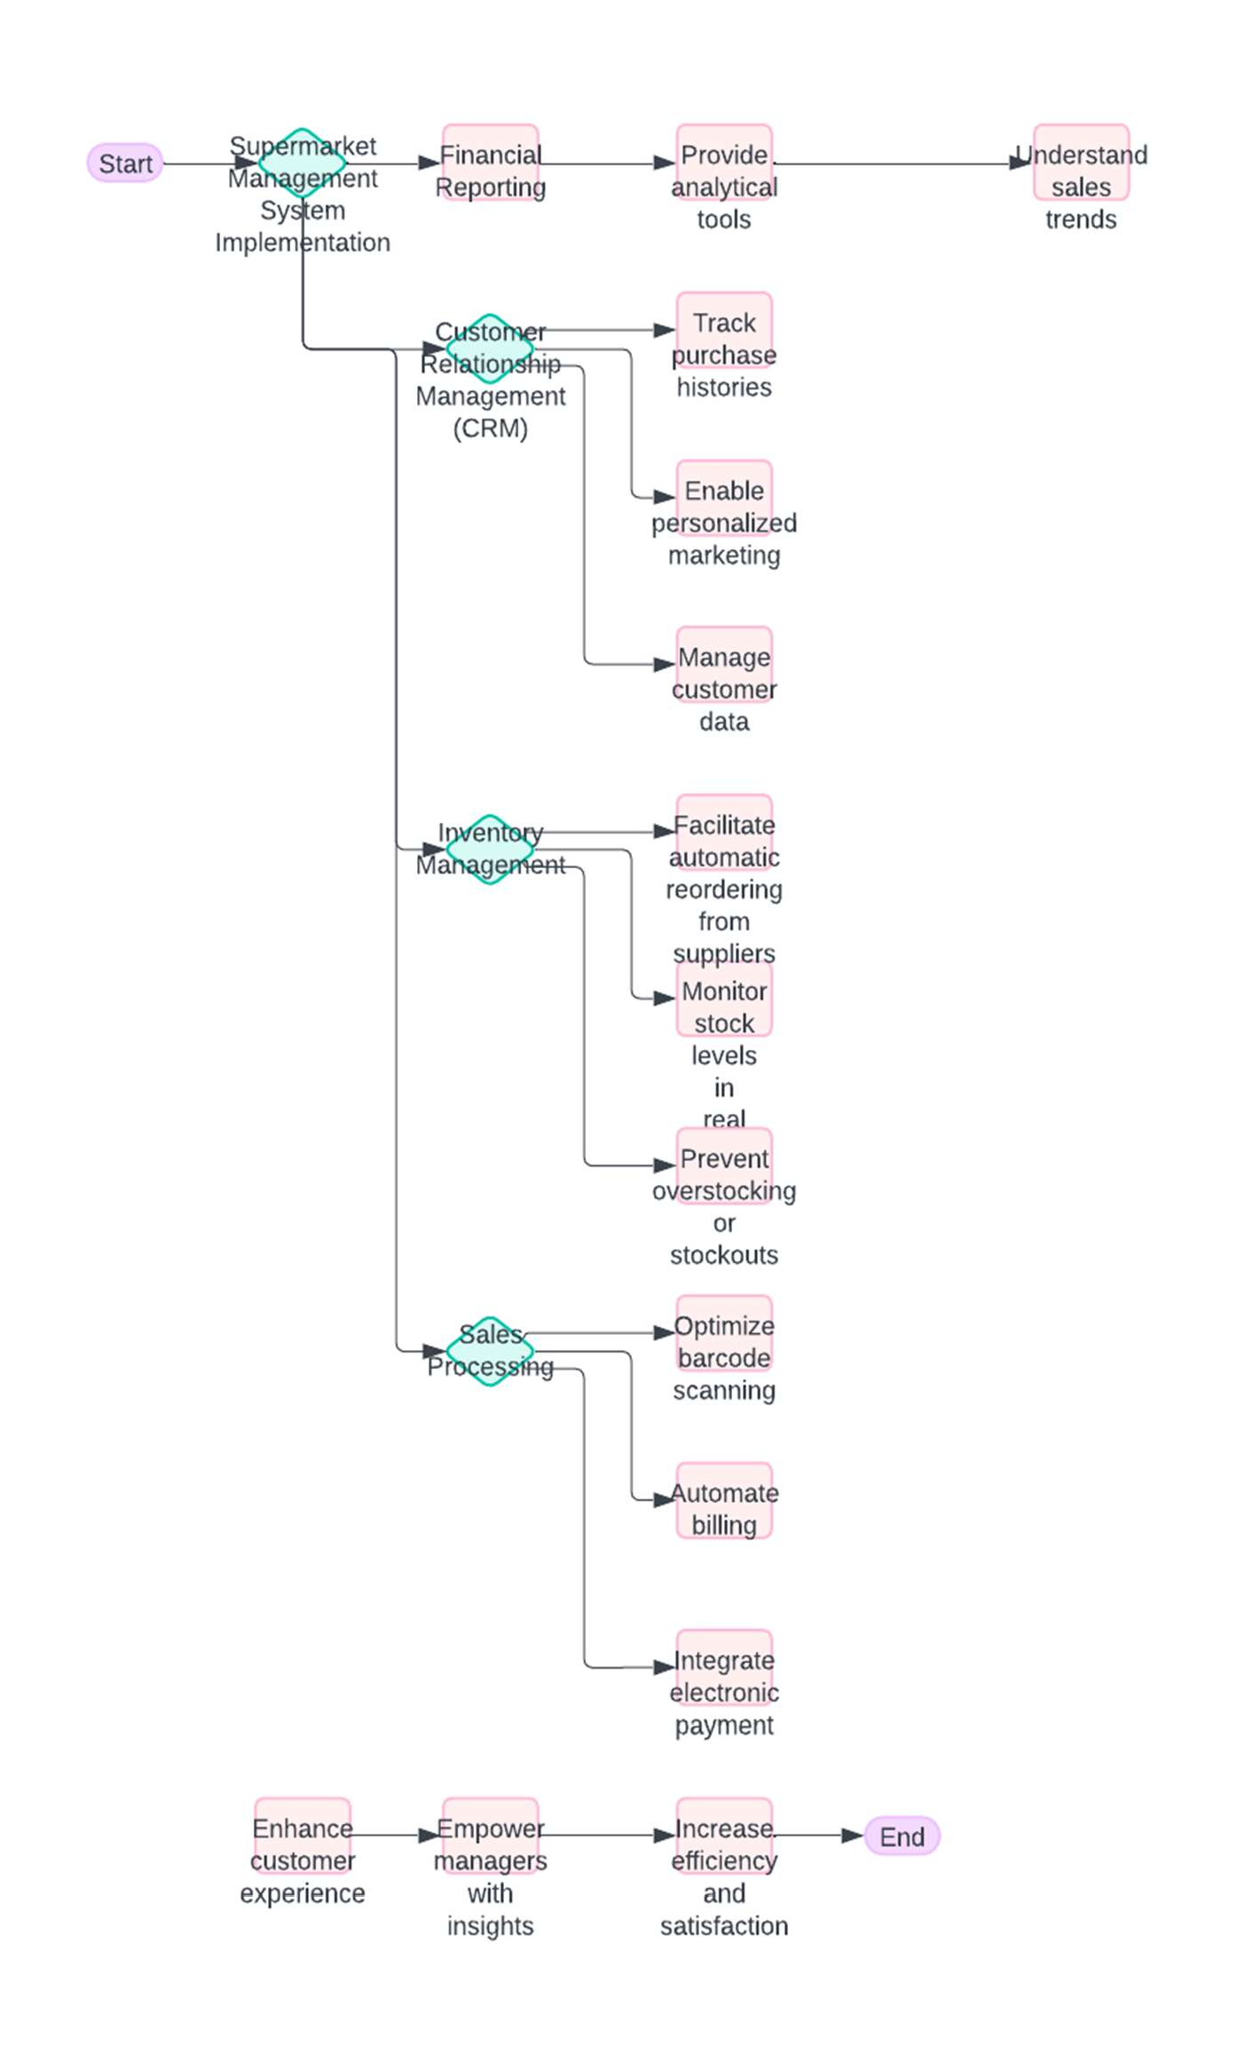

**CHAPTER 6 SAMPLE CODING**

<!DOCTYPE html>

<html lang="en">

<head>

<meta charset="UTF-8">

<meta name="viewport" content="width=device-width, initial-scale=1.0">

<title>Sakthiman Super Market - Products</title>

<link rel="stylesheet" href="{{ url_for('static', filename='css/product.css') }}">

<script src="{{ url_for('static', filename='js/product.js') }}" defer></script>

</head>

<body >

<!-- Navigation Menu -->

<header>

<nav>

<ul class="menu">

<li><a href="{{ url_for('homepage') }}">Home</a></li>

<li><a href="{{ url_for('products') }}">Products</a></li>

<li><a href="{{ url_for('inventory') }}">Inventory</a></li>

<li><a href="{{ url_for('sales_billing') }}">Sales</a></li>

<li><a href="{{ url_for('crm') }}">Customer</a></li>

<li><a href="{{ url_for('financial_report') }}">Financial Report</a></li>

</ul>

</nav>

</header>

<!-- Parallax Section -->

<div class="parallax-section">

<h1>Our Products</h1>

</div>

<!-- Product Cards Section -->

<section class="product-section" id="productSection">

<!-- Product cards will be populated here -->

</section>

</body>

</html>

**CHAPTER 7**

**SCREEN SHOTS**

Fig. 7.1. HOME

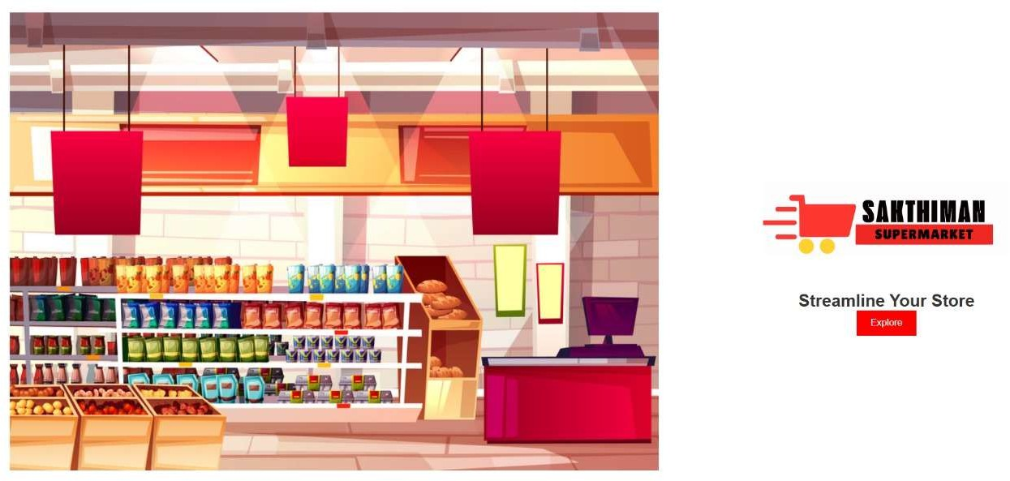

Fig.7.2. PRODUCT

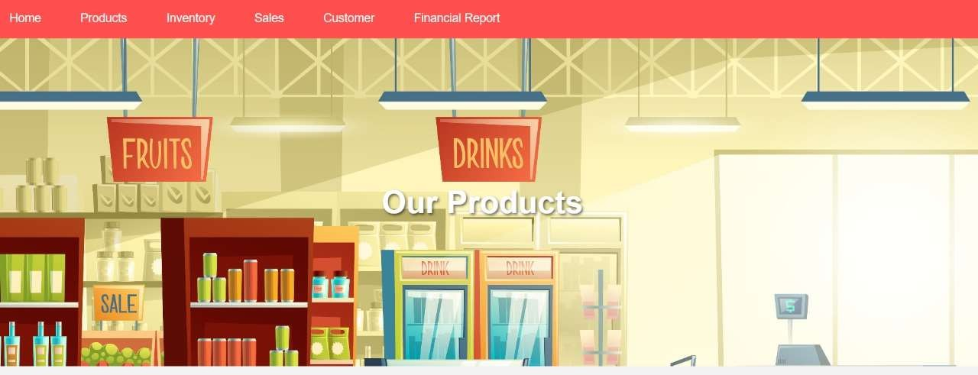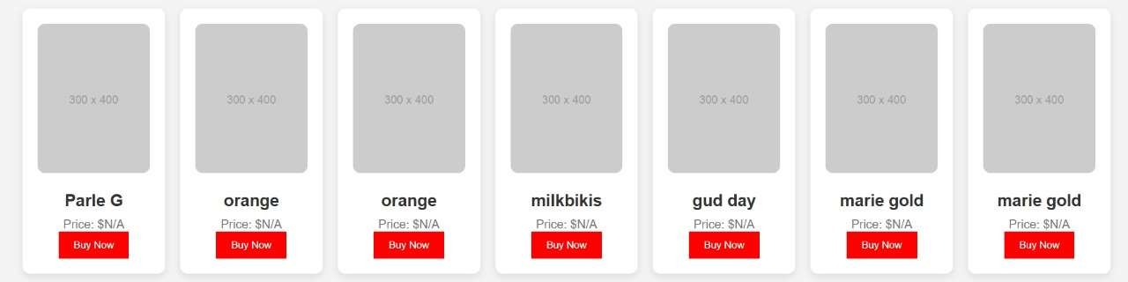

Fig. 7.3 INVENTORY

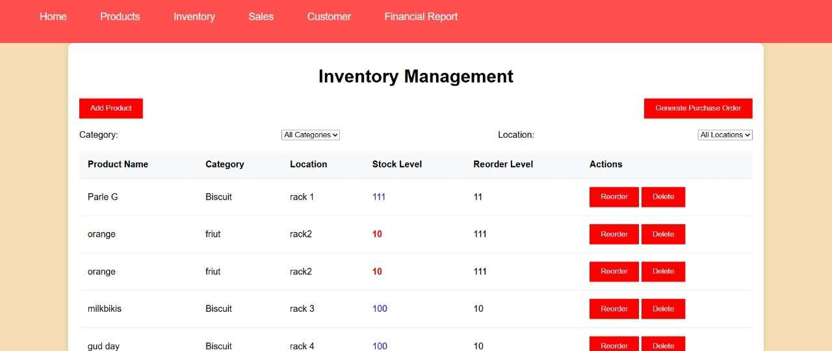

Fig.7.4 SALES

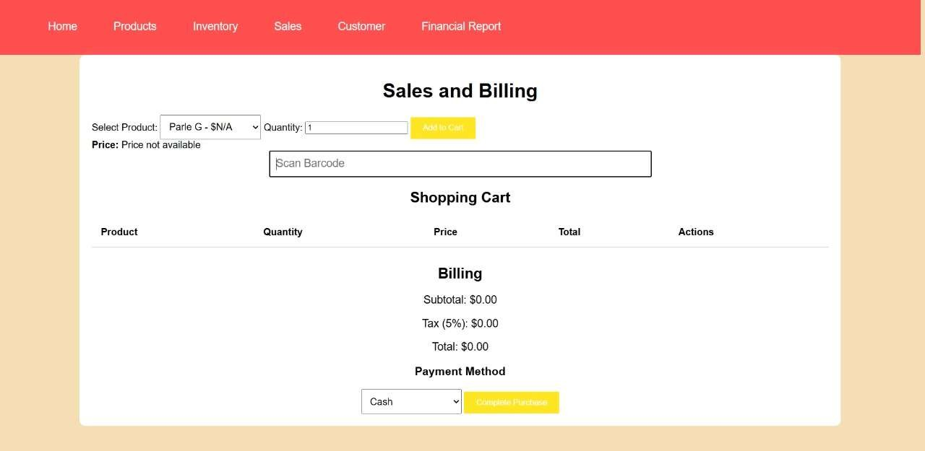

**CHAPTER 8**

**CONCLUSION**

The Electricity Bill Management System is a robust and comprehensive platform designed to streamline the entire process of electricity billing and management, benefiting both customers and administrators. It integrates various essential modules, including secure user registration and login, allowing customers to easily create accounts, access their billing information, and make payments. The system's core functionality revolves around the efficient generation, tracking, and management of electricity bills, with automated calculations ensuring accuracy in billing based on consumption data. The Admin Module enables administrators to manage user accounts, oversee billing operations, update tariff plans, and monitor payments, providing complete control over the system.

In addition to handling routine operations, the system incorporates advanced testing capabilities, such as the User Testing and Testing Status modules, which ensure that every feature is thoroughly tested for functionality, usability, performance, and security before deployment. The Testing Status Module provides a transparent, real-time view of the progress of testing, helping developers and managers track the readiness of the system. Security features, including encrypted password storage, session management, and role-based access controls, ensure that sensitive customer data is protected, and unauthorized access is prevented.

Furthermore, the system’s user-friendly design, cross-device compatibility, and seamless integration with external services like payment gateways and notification systems make it highly efficient and accessible for a wide range of users. By automating various processes, such as billing generation, payment tracking, and report generation, the Electricity Bill Management System reduces manual errors, improves operational efficiency, and ensures timely payments. Ultimately, this system provides a scalable, secure, and reliable solution for managing electricity consumption and billing, benefiting electricity providers and customers alike.

**REFERENCES**

1. HTML , CSS , JS – [www.w3schools.com](http://www.w3schools.com/)
2. PHP, MYSQL – [www.youtube.com](http://www.youtube.com/)
3. Product Details– [www.amazon.in](http://www.amazon.in/)
4. Carousel Slider – [www.glidejs.com](http://www.glidejs.com/)
5. Font Awesome Icons – [www.fontawesome.com](http://www.fontawesome.com/)
6. PHP Mailer - https://github.com/PHPMailer/PHPMailer
7. SweetAlert2 - https://sweetalert2.github.io/v10.html